Question 7  This question is about attempts to prevent illness.  To what extent was the application of science the most important development to the attempts to prevent illness and disease?  [16 +4] |  |  | Unit 3: Health and Medicine  Question Booklet 1  - Name:  Total: Grade:  Target:
Total

SPaG

Question 1  This question is about treatment and care .  Complete the sentences below with an accurate term: [4]  A famous family of Welsh doctors during the medieval period were the physicians of……………….  Medieval doctors often based their diagnosis on the chart of the……………………..  The development of radiation was pioneered by…………………………….  Dr Christian Barnard was best remembered for……………………………..  Question 2  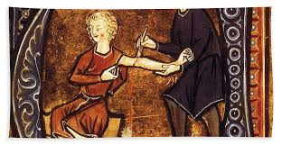  This question is about ways to treat illness.  Source A  Bloodletting from an illuminated medieval manuscript  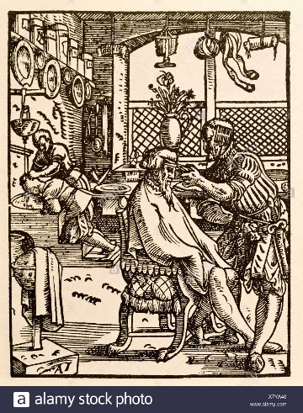  Source B Engraving of a barber surgeon 1568 |  |  | Question 6  This question is about causes of illness and disease.  Explain why the lack of hygiene of the medieval and early modern towns was important in causing the spread of illness and disease. [12]
 |  |  | 5

Question 5  This question is about ways to prevent illness.  Explain why Jenner’s vaccination was important in preventing illness. [12] |  |  | 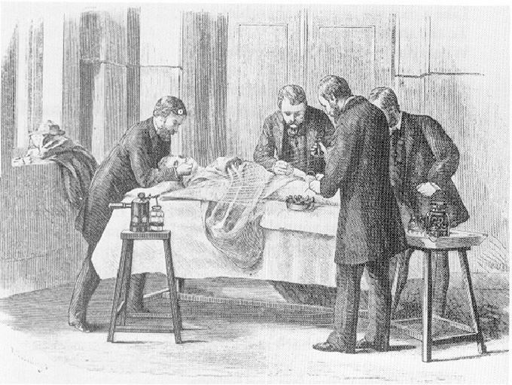  Source C  An operation in progress during the 1870s using Lister’s new Carbolic spray.  Use sources A, B and C to identify one similarity and one difference in the treatment of illness and disease over time.[4]
4 |  |  | 1

Question 3  This question is about attempts to treat illness.  Describe development and use of antiseptics in the 19th century. [6] |  |  | Question 4  This question is about attempts to prevent illness.  Describe the early methods of prevention with reference to the Black Death. [6]
2

