Question 7  This question is about attempts to treat and cure.  To what extent was the work of Joseph Lister the most important development for treatment and cure of illness and disease?  [16 +4] |  |  | Unit 3: Health and Medicine  Question Booklet 2  - Name:  Total: Grade:  Target:
Total

SPaG

Question 1  Complete the sentences below with an accurate term: [4]  The Black Death was spread by fleas living on ……………………  Edward Jenner is best known for his work with …………………………  The link between germs and disease was investigated by Louis …………...  The Cholera epidemic appear in Cardiff in …………….  Question 2  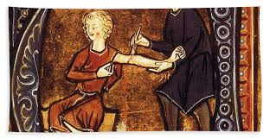  This question is about.  Source A  A man being bled using leeches during medieval times  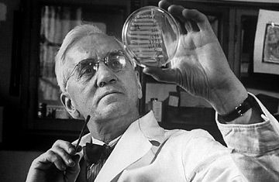  Source B  Professor Alexander Fleming and Penicillin |  |  | Question 6  This question is about attempts to treat and cure.  How effective was the development and use of antiseptics as a method of treating and curing illness in the 19th Century? [12]
 |  |  | 5

Question 5  Explain why the work of Pasteur and Koch was important in the advancement of medical knowledge during the 19th and 20th Centuries. [12] |  |  | Source C  A patient undergoing radiation therapy  Use sources A, B and C to identify one similarity and one difference in treatment of illness over time.[4]
4 |  |  | 1

Question 3  This question is about the historical site.  Describe the living conditions in industrial towns, such as Cardiff, that lead to cholera outbreaks in the mid-nineteenth century. [6] |  |  | Question 4  This question is about attempts to treat and cure.  Describe the roles of Fleming, Florey and Chain. [6]
2

