DISTINCTIVE LANDSCAPES
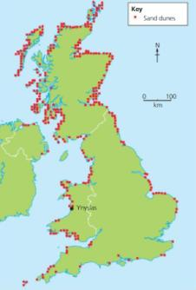
What is ‘place’?
__________________________________________________________________
Describe this distribution of sand dunes in the UK.
__________________________________________________________________
__________________________________________________________________
__________________________________________________________________
What is a honeypot site?
__________________________________________________________________
Why are honeypot sites under threat?
_______________________________________________________________________________________________________________________________________________________________________________________________________________________________________________________________________________________________________________________________________________________________________________________
CASE STUDY: The Lake District, England.
Why do people visit the Lake District? | What problems are created by tourism in the Lake District? | How are the problems being resolved in the Lake District?

RIVERS
What is erosion?
__________________________________________________________________________________
Define the following keywords of river erosion:
- Hydraulic Action: ______________________________________________________________________________________________________________________________________________________

- Solution
______________________________________________________________________________________________________________________________________________________

- Abrasion
______________________________________________________________________________________________________________________________________________________

- Attrition
______________________________________________________________________________________________________________________________________________________

What is transportation?
__________________________________________________________________________________
Define the following keywords of river transportation:
- Solution
______________________________________________________________________________________________________________________________________________________

- Saltation
______________________________________________________________________________________________________________________________________________________

- Suspension
_____________________________________________________________________________________________________________________________________________________

- Traction
______________________________________________________________________________________________________________________________________________________

What is a meander?
__________________________________________________________________________________
What is lateral erosion?
__________________________________________________________________________________
Draw a diagram to show meander formation. Include annotations.

Using the diagram, and specific terminology, explain how a meander is formed.
______________________________________________________________________________________________________________________________________________________________________________________________________________________________________________________________________________________________________________________________________________________________________________________________________________________________________________________________________________________________________________________________________________________________________________________________________________________________________________________________________________________________________________________________________________________________________________
What is a waterfall?
__________________________________________________________________________________
What is vertical erosion?
__________________________________________________________________________________
Draw a diagram to show waterfall formation. Include annotations.

Using the diagram, and specific terminology, explain how a waterfall is formed.
______________________________________________________________________________________________________________________________________________________________________________________________________________________________________________________________________________________________________________________________________________________________________________________________________________________________________________________________________________________________________________________________________________________________________________________________________________________________________________________________________________________________________________________________________________________________________________
What do the words, ‘impermeable’ and ‘permeable’ mean?
____________________________________________________________________________________________________________________________________________________________________
Explain two physical causes of flooding.
________________________________________________________________________________________________________________________________________________________________________________________________________________________________________________________________________________________________________________________________________
Explain two human causes of flooding
____________________________________________________________________________________________________________________________________________________________________
Complete the table below to outline the different impacts of flooding:
SOCIAL | ECONOMIC | ENVIRONMENTAL

How can we manage the effects of flooding?
STRATEGY | DESCRIPTION | ADVANTAGES | DISADVANTAGES
DAMS
LEVEES
AFFORESTATION

COASTS

How do waves form and gain their energy?
______________________________________________________________________________________________________________________________________________________________________________________________________________________________________________________
What is a concordant coastline?
__________________________________________________________________________________
What is a discordant coastline?
__________________________________________________________________________________
Define the following keywords of coastal erosion:
- Hydraulic Action
______________________________________________________________________________________________________________________________________________________
- Solution
______________________________________________________________________________________________________________________________________________________
- Abrasion
______________________________________________________________________________________________________________________________________________________
- Attrition
______________________________________________________________________________________________________________________________________________________
Draw a diagram to show how a wave cut notch forms and develops into a wave cut platform. Include annotations.

Using the diagram, and specific terminology, explain how a wave cut platform is formed.
______________________________________________________________________________________________________________________________________________________________________________________________________________________________________________________________________________________________________________________________________________________________________________________________________________________________________________________________________________________________________________________________________________________________________________________________________________________________________________________________________________________________________________________________________________________________________________

Draw a diagram to show how a coastal stack is formed. Include annotations.

Using the diagram, and specific terminology, explain how a coastal stack is formed
______________________________________________________________________________________________________________________________________________________________________________________________________________________________________________________________________________________________________________________________________________________________________________________________________________________________________________________________________________________________________________________________________________________________________________________________________________________________________________________________________________________________________________________________________________________________________________

What is longshore drift? How does this process work along coastal environments?
________________________________________________________________________________________________________________________________________________________________________________________________________________________________________________________________________________________________________________________________________

Draw a diagram, including annotations, to help explain the process of longshore drift.

CASE STUDY: The Winter Storms of 2014.
Complete the table below to outline the different impacts of coastal flooding:
SOCIAL | ECONOMIC | ENVIRONMENTAL

How can we manage the coastline?
STRATEGY | DESCRIPTION | ADVANTAGES | DISADVANTAGES
SEA WALLS
GROYNES
BEACH REPLENISHMENT/
NOURISHMENT

RURAL-URBAN LINKS

POPULATION AND RURAL-URBAN CHANGE

What is a sphere of influence?
__________________________________________________________________________________
Why does a village shop have a smaller sphere of influence than a shop in a town?
______________________________________________________________________________________________________________________________________________________________________________________________________________________________________________________
Why do people travel from rural areas to urban areas?
________________________________________________________________________________________________________________________________________________________________________________________________________________________________________________________________________________________________________________________________________
How can rural life be challenging for the younger generations?
________________________________________________________________________________________________________________________________________________________________________________________________________________________________________________________________________________________________________________________________________
How can rural life be challenging for the older generations?
________________________________________________________________________________________________________________________________________________________________________________________________________________________________________________________________________________________________________________________________________
What is commuting?
__________________________________________________________________________________
Why has commuting increased since the 1960s?
______________________________________________________________________________________________________________________________________________________________________________________________________________________________________________________

Why are more people working from home since the 1960s?
______________________________________________________________________________________________________________________________________________________________________________________________________________________________________________________
Why are a lot of houses in rural areas unaffordable?
________________________________________________________________________________________________________________________________________________________________________________________________________________________________________________________________________________________________________________________________________
What is deprivation?
__________________________________________________________________________________
What is depopulation?
__________________________________________________________________________________
Why are more people moving away from rural locations?
________________________________________________________________________________________________________________________________________________________________________________________________________________________________________________________________________________________________________________________________________
What problems are created by an ageing population in rural areas?
______________________________________________________________________________________________________________________________________________________________________________________________________________________________________________________
What does sustainable mean?
__________________________________________________________________________________
Why could the closure of a village shop and local schools be challenging for rural areas?
________________________________________________________________________________________________________________________________________________________________________________________________________________________________________________________________________________________________________________________________________

POPULATION AND URBAN CHANGE

Define these key words:
- Average life expectancy
___________________________________________________________________________
- Birth rate
___________________________________________________________________________
- Death rate
___________________________________________________________________________
- Migration
___________________________________________________________________________

How and why is the UK’s population changing?
________________________________________________________________________________________________________________________________________________________________________________________________________________________________________________________________________________________________________________________________________
What problems can an ageing population cause the UK?
______________________________________________________________________________________________________________________________________________________________________________________________________________________________________________________
Why is there migration into the UK?
________________________________________________________________________________________________________________________________________________________________________________________________________________________________________________________________________________________________________________________________________
How can migration impact the UK’s population?
__________________________________________________________________________________________________________________________________________________________________________________________________________________________________________________________________________________________________________________________________________________________________________________________________________________________
CASE STUDY: Garden Cities: Ebbsfleet, Kent.
 | Arguments FOR building new homes in Ebbsfleet | Arguments AGAINST building new homes in Ebbsfleet
SOCIAL
ECONOMIC
ENVIRONMENTAL

What is a sustainable community?
__________________________________________________________________________________
CASE STUDY: BedZED
LOCATION | AIMS | FEATURES

How is a greenfield site different to a brownfield site?
______________________________________________________________________________________________________________________________________________________________________________________________________________________________________________________
What is NIMBYism?
__________________________________________________________________________________
Why is the demand for homes around urban areas increasing?
________________________________________________________________________________________________________________________________________________________________________________________________________________________________________________________________________________________________________________________________________
What is urban renewal?
__________________________________________________________________________________
CASE STUDY: Ipswich
AIM | FEATURES | EFFECTIVENESS

What is the Central Business District? (CBD)
__________________________________________________________________________________

Discuss the advantages and disadvantages for the consumer of each retail location by completing the following table:
RETAIL LOCATION | ADVANTAGES | DISADVANTAGES
Town centre high street locations
Town centre shopping centres
District/suburban shopping centres
Out-of-town retail sites

How is technology changing how and where we shop?
______________________________________________________________________________________________________________________________________________________________________________________________________________________________________________________
Complete the table below by highlighting 3 positive and negative impacts of online shopping:
POSITIVE IMPACTS OF ONLINE SHOPPING | NEGATIVE IMPACTS OF ONLINE SHOPPING

How are high streets improving their services to re-attract potential customers?
______________________________________________________________________________________________________________________________________________________________________________________________________________________________________________________

GLOBAL CITIES
What is an NIC? Name 3 examples.
__________________________________________________________________________________

What is urbanisation?
__________________________________________________________________________________
How many people are needed for a city to become a mega-city?
__________________________________________________________________________________
What is globalisation?
__________________________________________________________________________________
How does a city become a ‘global city’?
________________________________________________________________________________________________________________________________________________________________________________________________________________________________________________________________________________________________________________________________________
CASE STUDY: Mumbai, India.
What is an informal settlement?
__________________________________________________________________________________
Describe the key features of an informal settlement.
______________________________________________________________________________________________________________________________________________________________________________________________________________________________________________________
Why do people who live in Mumbai’s informal settlements have a poor quality of life?
________________________________________________________________________________________________________________________________________________________________________________________________________________________________________________________________________________________________________________________________________
Explain why demolishing informal housing next to railway lines could improve railway safety in Mumbai.
________________________________________________________________________________________________________________________________________________________________________________________________________________________________________________________________________________________________________________________________________
What is a push factor?
__________________________________________________________________________________
What is a pull factor?
__________________________________________________________________________________
Why are more people migrating to Mumbai?
________________________________________________________________________________________________________________________________________________________________________________________________________________________________________________________________________________________________________________________________________

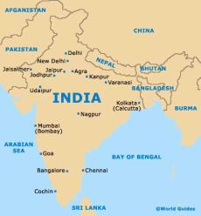
Explain why the location of Mumbai has given the city an economic advantage over other Indian cities?
_________________________________________________________________
_________________________________________________________________
__________________________________________________________________
__________________________________________________________________
How does Mumbai’s informal sector of its employment industry, aid the growth of the city?
________________________________________________________________________________________________________________________________________________________________________________________________________________________________________________________________________________________________________________________________________
Suggest how each of the following might affect the safety and health of local residents:
Overcrowding in the chawls:
______________________________________________________________________________________________________________________________________________________________________________________________________________________________________________________
Having to share toilet facilities:
______________________________________________________________________________________________________________________________________________________________________________________________________________________________________________________
Insecurity of tenure for pavement dwellers:
______________________________________________________________________________________________________________________________________________________________________________________________________________________________________________________

CASE STUDY: Cardiff, Wales.
Describe how Cardiff changed between 1920 and the present day. Use the following specialist terms in your answer: suburban sprawl, inner urban and re-urbanisation.
________________________________________________________________________________________________________________________________________________________________________________________________________________________________________________________________________________________________________________________________________
What is an economic migrant?
__________________________________________________________________________________

How does Cardiff’s growth compare with that of Mumbai? Consider the importance of natural increase and migration patterns in both cities.
__________________________________________________________________________________________________________________________________________________________________________________________________________________________________________________________________________________________________________________________________________________________________________________________________________________________
What is standard of living?
__________________________________________________________________________________
What is quality of life?
__________________________________________________________________________________
What is deprivation?
__________________________________________________________________________________
Why might areas depopulate due to deprivation?
__________________________________________________________________________________________________________________________________________________________________________________________________________________________________________________________________________________________________________________________________________________________________________________________________________________________

WEATHER, CLIMATE AND ECOSYSTEMS.

CLIMATE CHANGE DURING THE QUATERNARY

Use the table below to explain the natural causes of climate change:
CAUSE | DIAGRAM | EXPLANATION
MILANKOVITCH CYCLES | 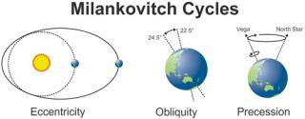
SUNSPOT ACTIVITY | 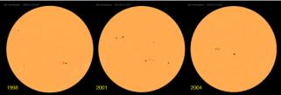
VOLCANIC ERUPTIONS | 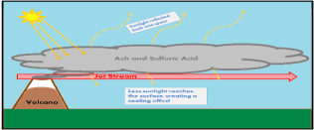
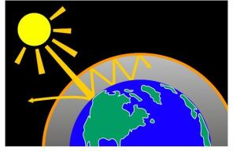
What is the greenhouse effect?
__________________________________________________
__________________________________________________
__________________________________________________
What is a carbon sink?
__________________________________________________________________________________
How have people’s actions impacted the greenhouse effect?
________________________________________________________________________________________________________________________________________________________________________________________________________________________________________________________________________________________________________________________________________
Describe the trend created by the Keeling Curve (3 marks)
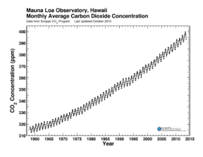
___________________________________________________
___________________________________________________
___________________________________________________
___________________________________________________
___________________________________________________

Use your understanding of the greenhouse effect to explain why reduced levels of carbon dioxide in the atmosphere might be linked to a cooler period in climate.
__________________________________________________________________________________________________________________________________________________________________________________________________________________________________________________________________________________________________________________________________________________________________________________________________________________________

EXTREME WEATHER

What is a low pressure system? What weather hazards do they create?
____________________________________________________________________________________________________________________________________________________________________
Describe the global distribution of tropical storms.
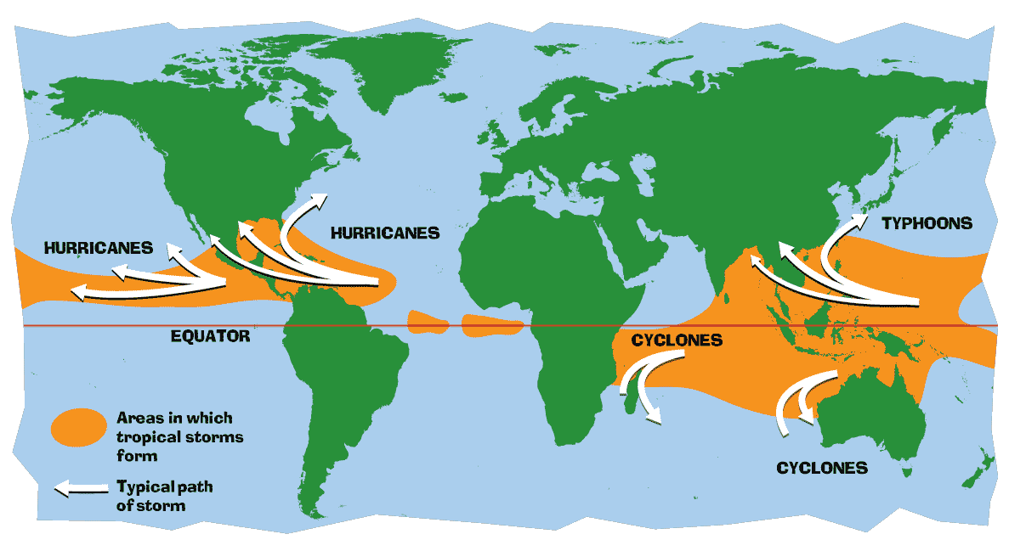
____________________________________________
____________________________________________
____________________________________________
____________________________________________
____________________________________________

Why do cyclones form? Use the diagram to help your explanation.
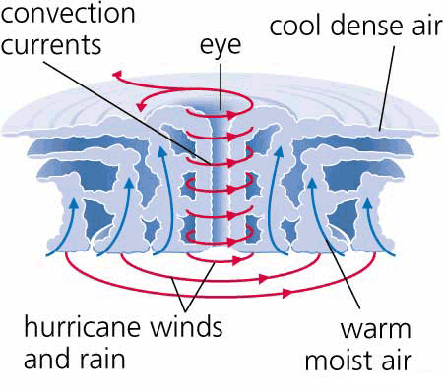
___________________________________________________
___________________________________________________
___________________________________________________
___________________________________________________
___________________________________________________
___________________________________________________
___________________________________________________
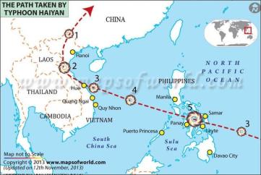
CASE STUDY: TYPHOON HAIYAN
Describe the location of Typhoon Haiyan in 2013.
__________________________________________________
__________________________________________________
__________________________________________________
__________________________________________________

Impacts of Typhoon Haiyan:
SOCIAL | ECONOMIC | ENVIRONMENTAL

What is a high pressure system? What weather hazards do they create?
____________________________________________________________________________________________________________________________________________________________________
Describe the global distribution of droughts
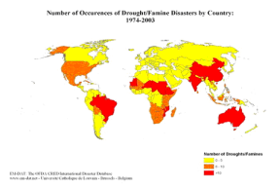
____________________________________________
____________________________________________
____________________________________________
____________________________________________
____________________________________________
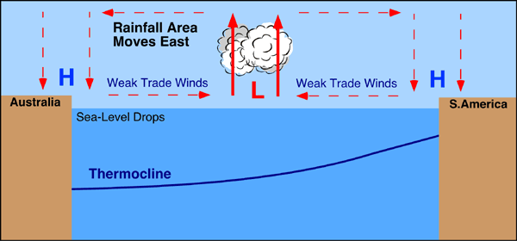
Why do droughts happen? Use the diagram to help your explanation.
___________________________________________________
___________________________________________________
___________________________________________________
___________________________________________________
____________________________________________________________________________________________________________________________________________________________________
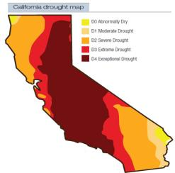
CASE STUDY: CALIFORNIAN DROUGHTS 2015
Describe the location of the Californian drought in 2015.
_______________________________________________________
_______________________________________________________
_______________________________________________________

Impacts of the drought in California:
SOCIAL | ECONOMIC | ENVIRONMENTAL

UK WEATHER AND CLIMATE

What is aspect? How can this influence weather in the UK?
____________________________________________________________________________________________________________________________________________________________________
What is altitude? How can this influence weather in the UK?
____________________________________________________________________________________________________________________________________________________________________

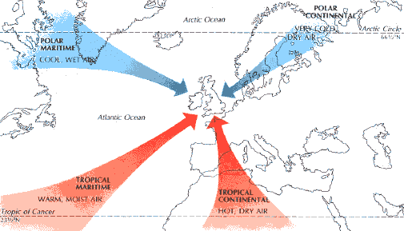
Use the diagram and explain how air masses affect the UK.
________________________________________________
________________________________________________
________________________________________________
________________________________________________
________________________________________________
__________________________________________________________________________________
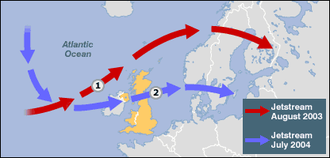
How does the jet stream affect the UK’s weather?
_____________________________________________
_____________________________________________
_____________________________________________
_____________________________________________
_____________________________________________
__________________________________________________________________________________

CASE STUDY: WINTER STORMS OF 2014
Why did the Winter Storms happen?
______________________________________________________________________________________________________________________________________________________________________________________________________________________________________________________
Impacts of the Winter Storms:
SOCIAL | ECONOMIC | ENVIRONMENTAL

What is a microclimate?
__________________________________________________________________________________
How do cities affect wind and rainfall patterns?
______________________________________________________________________________________________________________________________________________________________________________________________________________________________________________________

ECOSYSTEMS
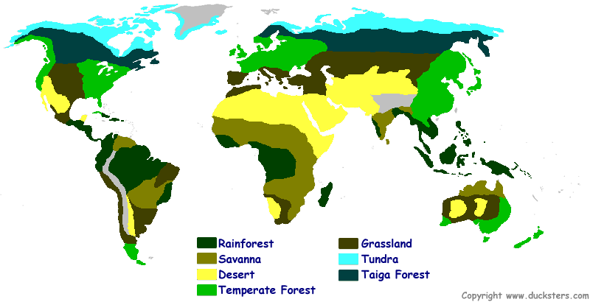

CASE STUDY: TROPICAL RAINFORESTS
Where in the world do we find tropical rainforests?
____________________________________________________________________________________________________________________________________________________________________
Describe the characteristics of the tropical rainforest
______________________________________________________________________________________________________________________________________________________________________________________________________________________________________________________
How does the nutrient cycle work in the tropical rainforest? Why is it important?
________________________________________________________________________________________________________________________________________________________________________________________________________________________________________________________________________________________________________________________________________
How is the rainforest under threat by human activity? What impacts could this have?
__________________________________________________________________________________________________________________________________________________________________________________________________________________________________________________________________________________________________________________________________________________________________________________________________________________________
How can we sustainably manage the rainforest ecosystem?
______________________________________________________________________________________________________________________________________________________________________________________________________________________________________________________
CASE STUDY: SEMI ARID ECOSYSTEMS (SAVANNA)
Where in the world do we find semi-arid ecosystems?
____________________________________________________________________________________________________________________________________________________________________
Describe the characteristics of the semi-arid ecosystem
______________________________________________________________________________________________________________________________________________________________________________________________________________________________________________________
How does vegetation adapt to the hot, dry climate? Include a named example.
________________________________________________________________________________________________________________________________________________________________________________________________________________________________________________________________________________________________________________________________________
How is the semi-arid ecosystem under threat by human activity? What impacts could this have?
__________________________________________________________________________________________________________________________________________________________________________________________________________________________________________________________________________________________________________________________________________________________________________________________________________________________
How can we sustainably manage the semi-arid ecosystem?
______________________________________________________________________________________________________________________________________________________________________________________________________________________________________________________

CASE STUDY: MARINE POWER
How is the marine environment used for energy production?
______________________________________________________________________________________________________________________________________________________________________________________________________________________________________________________
Explain the aims of the Swansea Bay Tidal Lagoon project.
__________________________________________________________________________________________________________________________________________________________________________________________________________________________________________________________________________________________________________________________________________________________________________________________________________________________

DEVELOPMENT AND RESOURCE ISSUES

GLOBAL INEQUALITIES

What is Gross National Income (GNI)?
__________________________________________________________________________________
Define these following indictors of development:
Birth rate
__________________________________________________________________________________
Death rate
__________________________________________________________________________________
Fertility rate
__________________________________________________________________________________
People per Doctor
__________________________________________________________________________________
Literacy rate
__________________________________________________________________________________
Infant mortality rate
__________________________________________________________________________________

What is a multi-national company?
__________________________________________________________________________________
What is globalisation?
__________________________________________________________________________________
CASE STUDY: NIKE
Why does Nike outsource their work?
______________________________________________________________________________________________________________________________________________________________________________________________________________________________________________________
Complete the table to highlight the advantages and disadvantages of multi-national companies like Nike:
ADVANTAGES | DISADVANTAGES

Explain the economic, social and environmental impacts of rapid growth in NICs:
ECONOMIC | SOCIAL | ENVIRONMENTAL

What is free trade?
__________________________________________________________________________________
Why can trade aid a country’s development?
________________________________________________________________________________________________________________________________________________________________________________________________________________________________________________________________________________________________________________________________________
How can trade create global inequality?
________________________________________________________________________________________________________________________________________________________________________________________________________________________________________________________________________________________________________________________________________
Why can tourism be beneficial to a country?
________________________________________________________________________________________________________________________________________________________________________________________________________________________________________________________________________________________________________________________________________
Why can tourism be problematic to a country?
________________________________________________________________________________________________________________________________________________________________________________________________________________________________________________________________________________________________________________________________________
What are the Millennium Development Goals (MDG)?
____________________________________________________________________________________________________________________________________________________________________

What is bilateral aid?
__________________________________________________________________________________
What is multi-lateral aid?
__________________________________________________________________________________
What is emergency aid?
__________________________________________________________________________________
CASE STUDY: MALAWI
PROBLEMS | SOLUTIONS | EFFECTIVENESS

What is fair trade?
__________________________________________________________________________________
How does the Kuapa Kokoo co-operative help cocoa farmers in Ghana?
________________________________________________________________________________________________________________________________________________________________________________________________________________________________________________________________________________________________________________________________________

WATER RESOURCES AND THEIR MANAGEMENT

What is a water footprint?
__________________________________________________________________________________
Use the data in the graph, and compare global water use in 2000 and 2050.
__________________________________________________
__________________________________________________
__________________________________________________
__________________________________________________
__________________________________________________
__________________________________________________
________________________________________________

What is water security?
__________________________________________________________________________________
What is relief rainfall? How does it work?
________________________________________________________________________________________________________________________________________________________________________________________________________________________________________________________________________________________________________________________________________
CASE STUDY: LESOTHO HIGHLANDS WATER PROJECT (LHWP)
What is the LHWP?
____________________________________________________________________________________________________________________________________________________________________

ADVANTAGES OF LHWP | DISADVANTAGES OF LHWP
How can rainwater be harvested sustainably? Give 3 ways and explain how they work.

ADVANTAGES OF FOG HARVESTING | DISADVANTAGES OF FOG HARVESTING

What does over-abstraction mean?
__________________________________________________________________________________
Explain 2 reasons for the over-abstraction of water.
__________________________________________________________________________________________________________________________________________________________________________________________________________________________________________________________________________________________________________________________________________________________________________________________________________________________

What is top-down development?
__________________________________________________________________________________
CASE STUDY: COCA COLA IN INDIA
SOCIAL IMPACTS | ECONOMIC IMPACTS | ENVIRONMENTAL IMPACTS

How is coca-cola trying to rectify the problems created by the over-abstraction of water?
______________________________________________________________________________________________________________________________________________________________________________________________________________________________________________________

REGIONAL ECONOMIC DEVELOPMENT

What is inequality?
__________________________________________________________________________________
What is the informal sector?
__________________________________________________________________________________
Explain the UK’s ‘north-south’ divide.
________________________________________________________________________________________________________________________________________________________________________________________________________________________________________________________________________________________________________________________________________
Explain why a few, empty shops may lead to others closing.
________________________________________________________________________________________________________________________________________________________________________________________________________________________________________________________________________________________________________________________________________
Suggest why businesses might be more attracted to locations to the east of the M4/M11 corridor rather than the west.
________________________________________________________________________________________________________________________________________________________________________________________________________________________________________________________________________________________________________________________________________
Explain two solutions as to how regional inequalities in the UK can be reduced.
________________________________________________________________________________________________________________________________________________________________________________________________________________________________________________________________________________________________________________________________________

THEME 7: SOCIAL DEVELOPMENT

MEASURING SOCIAL DEVELOPMENT

What is social development?
__________________________________________________________________________________
How is social development measured?
______________________________________________________________________________________________________________________________________________________________________________________________________________________________________________________
What is infant mortality rate (IMR)?
__________________________________________________________________________________
What is average life expectancy?
__________________________________________________________________________________
Suggest reasons why life expectancy has increased in some countries more than others.
________________________________________________________________________________________________________________________________________________________________________________________________________________________________________________________________________________________________________________________________________
What is the Human Development Index? How can it help us to understand a country’s development?
________________________________________________________________________________________________________________________________________________________________________________________________________________________________________________________________________________________________________________________________________

CONTEMPORARY DEVELOPMENT ISSUES

Explain why some poor parents do not send all of their children to primary school.
______________________________________________________________________________________________________________________________________________________________________________________________________________________________________________________
Why is child labour an issue?
__________________________________________________________________________________________________________________________________________________________________________________________________________________________________________________________________________________________________________________________________________________________________________________________________________________________
Why is it particularly important to improve the education of girls?
__________________________________________________________________________________________________________________________________________________________________________________________________________________________________________________________________________________________________________________________________________________________________________________________________________________________
What is an economic migrant?
__________________________________________________________________________________
What is the difference between a refugee and an asylum seeker?
______________________________________________________________________________________________________________________________________________________________________________________________________________________________________________________
Why are people choosing to leave Lebanon?
________________________________________________________________________________________________________________________________________________________________________________________________________________________________________________________________________________________________________________________________________
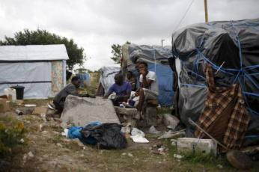
Use evidence from the photograph to suggest how living in the ‘Jungle’ in Calais, France, may affect quality of life for migrants.
____________________________________________
____________________________________________
____________________________________________

CASE STUDY: MALARIA
Explain why new cases of malaria are more common at certain times of the year.
________________________________________________________________________________________________________________________________________________________________________________________________________________________________________________________________________________________________________________________________________
How far do you agree with the following statement: malaria causes poverty more than it being a result of poverty?
________________________________________________________________________________________________________________________________________________________________________________________________________________________________________________________________________________________________________________________________________________________________________________________________________________________________________________________________________________________________________________________________________________________________________________________________________________________________________________________________________________

Name and describe 2 strategies used to combat malaria:

CASE STUDY: WATER INSECURITY IN KANO
What problems exist in the city of Kano?
______________________________________________________________________________________________________________________________________________________________________________________________________________________________________________________
What is the connection between water insecurity and polio in Kano?
________________________________________________________________________________________________________________________________________________________________________________________________________________________________________________________________________________________________________________________________________

ENVIRONMENTAL CHALLENGES

What does ‘ecological footprint’ mean?
______________________________________________________________________________________________________________________________________________________________________________________________________________________________________________________

What facotrs will increase a person’s ecological footprint?
______________________________________________________________________________________________________________________________________________________________________________________________________________________________________________________

Describe the factors that have led to the destruction of a tropical rainforest that you have studied.
____________________________________________________________________________________________________________________________________________________________________________________________________________________________________________________________________________________________________________________________________________________________________________________________________________________________________________________________________________________________________________

What is consumerism?
______________________________________________________________________________________________________________________________________________________________________________________________________________________________________________________

Explain why one biome that you have studied is being destroyed due to consumerism.
____________________________________________________________________________________________________________________________________________________________________________________________________________________________________________________________________________________________________________________________________________________________________________________________________________________________________________________________________________________________________________

Destruction of ecosystems is necessary if global indcependence is to continue. How far do you agree with this statement?
____________________________________________________________________________________________________________________________________________________________________________________________________________________________________________________________________________________________________________________________________________________________________________________________________________________________________________________________________________________________________________

Identify the long and short term impacts of climate change on Tuvalu.
__________________________________________________________________________________________________________________________________________________________________________________________________________________________________________________________________________________________________________________________________________________________________________________________________________________________________________________________________________________________________________________________________________________________________________________________________________________________________________________________________________________________________________________________________________________________________

