Skills Challenge Certificate/Welsh Baccalaureate
Individual Project

Name:
Tutor Group:
A research project is successful when it is

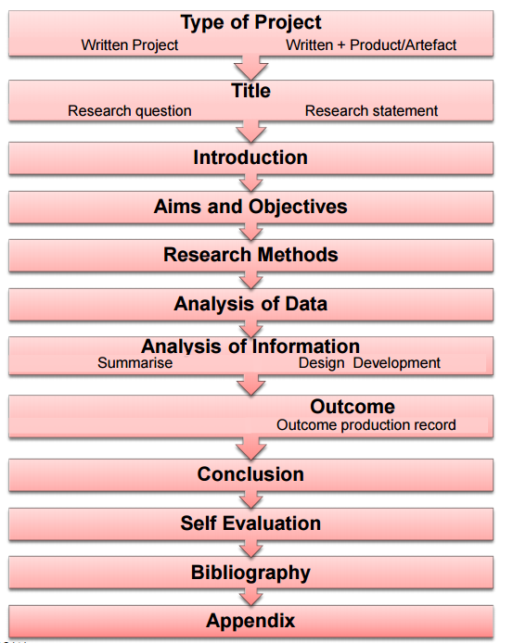
Stages of the Individual Project

Let’s be clear about what the headings on page 3 mean.
Make notes yourself or work with your teacher (National)
Section of Individual Project | What does this mean? | OK – do I understand?
Type of project
Title
Introduction
Aims and objectives
Research methods
Analysis of data
Analysis of information
Summarise (report only)
Design development (artefact only)
Outcome (artefact only)
Conclusion
Self Evaluation
Biography
Appendix

Next watch the video:- Student intro to IP

Initial Title Ideas for my Individual Project
Use the words
- What
- Where
- How
- When
- Why

Initial Ideas
Draw an Ideas tree
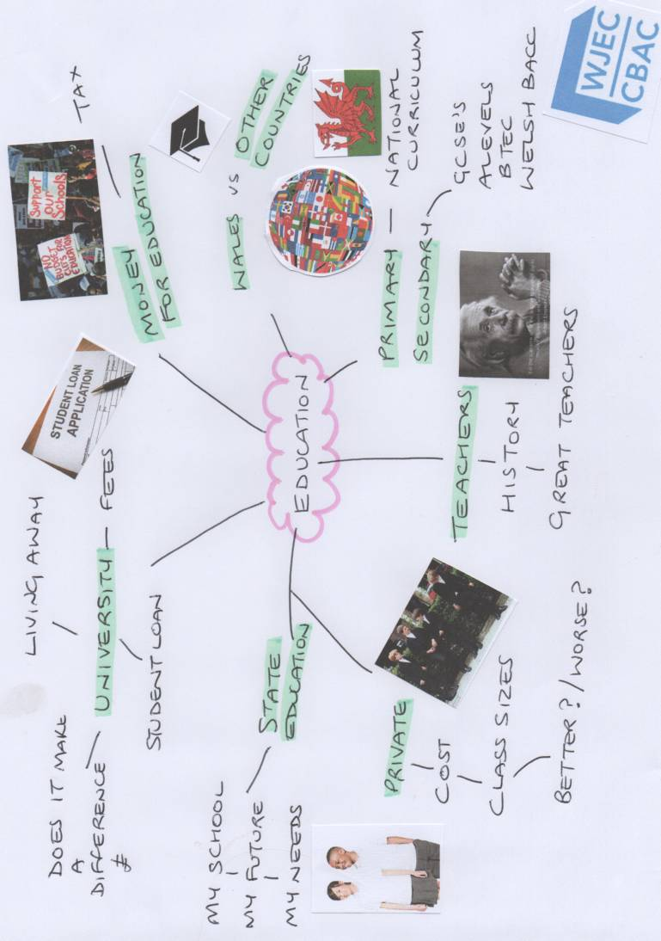

Example

Date: My Ideas Tree

My ‘Nearly’ Final I.P. Ideas
Idea No 1 | Answer | Score out of 10 for interest
Why does this I.P. idea appeal to me?
What do I hope to find out?
Does this I.P. idea fit in my future, interests or school?

Idea No 2 | Answer | Score out of 10 for interest
Why does this I.P. idea appeal to me?
What do I hope to find out?
Does this I.P. idea fit in my future, interests or school?

Idea No 3 | Answer | Score out of 10 for interest
Why does this I.P. idea appeal to me?
What do I hope to find out?
Does this I.P. idea fit in my future, interests or school?
Checking information exists to
support my Individual Project

Before you spend too much time on one or more of your topics, and before your make your final decisions, it is important that you are sure information exists to support your work.
Choose your ‘best topic’ (from table above). Find links to four pieces of reseach (try to find different types). Record the sources here. Write a quick note regarding what you have found.

Date:

I am happy to continue with my project idea because (summarise what you have found out in this checking research section)

Meet with your teacher to disucss your work so far
Date:
My Individual Project is going to based on……………………………..
I think this will be a good project for me
because…………………………………………………………………………
……………………………………………………………………………………

Individual Project Title
Choosing the right title for your Individual Project is important. It gives you a direction to head towards and it gives you a focus in your conclusion.
Your title should be a question to answer such as:
- Is studying A Level an advantage to a person’s future?
Or a hypothesis to test such as:
- Studying for A Levels creates the same long term income as getting an apprenticeship.
Tip! It is sometime easier to choose a question to answer.

Whilst is it best to come up with your own title, your teacher may be able to help you construct a title that will

Title 1 idea……………………………………………………………………

Title 2 idea…………………………………………………………………..

Title 3 idea…………………………………………………………………..

Now show your teach

Date | Activity | Next step – what do I need to do next?
 | Initial ideas
 | Contents of the IP
 | Ideas tree
 | Checking information exists to support my IP
 | Summarising ideas

