Join a class

- Log into HWB using Google Chrome Browser
- Use your HWB email address and password ( contact school if you need these details)
- Click on Google for Education
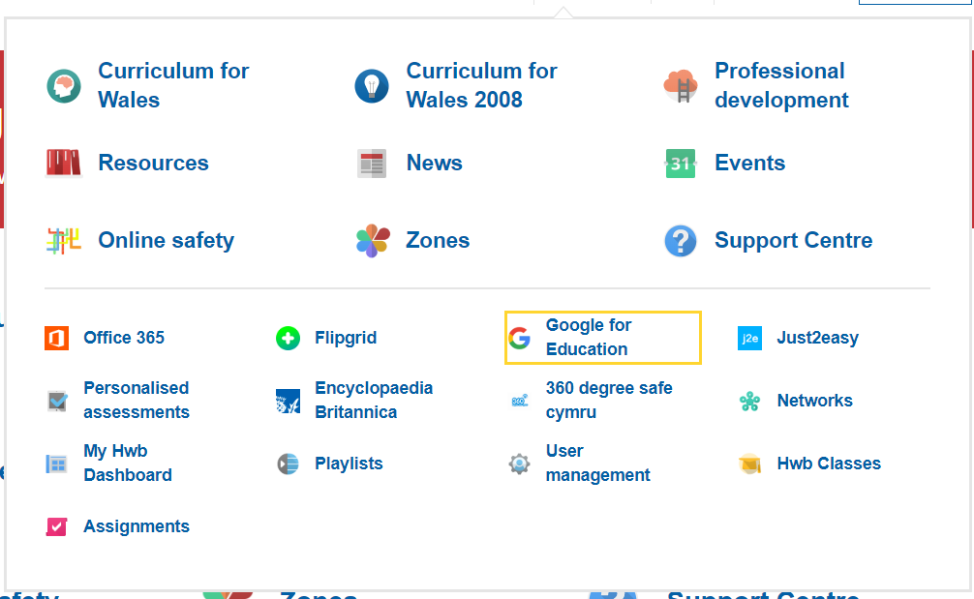

- Click on the plus sign to join a class
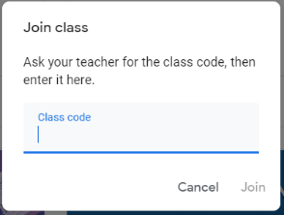
- Add the class code you received from your teacher
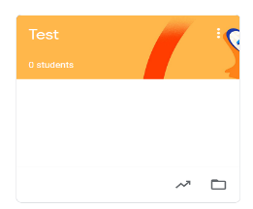
- View assignments and communicate with your teacher

