Step by step guide to accessing HWB.
Step 1: On your laptop or any other form of computer open up your web browser of choice, this can be google chrome, internet explorer, Microsoft edge or anything you use. Get yourself to the google home page to start!
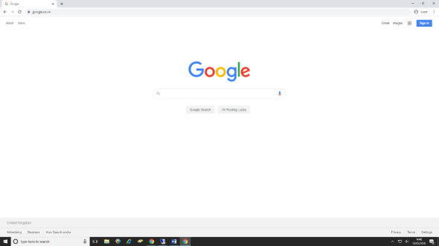

Step 2: In the Search bar right in the centre of the page, type in ‘HWB’, and hit the search button. Your search result should look like this! Select the very first Blue link on the page named ‘Hwb’
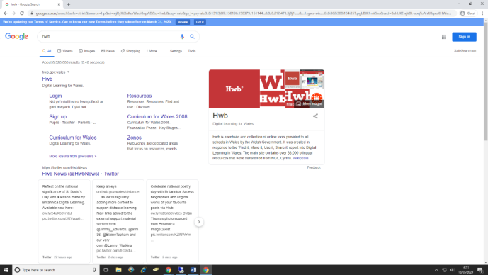

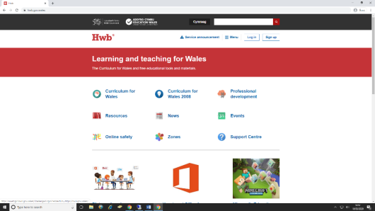
Step 3: After clicking the link to Hwb on the page, you should now be on the main page which looks like this:

The next stage from here is to click the button at the top of the page which says ‘Log In’

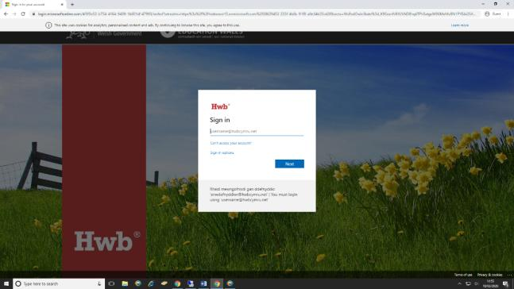
You should now be taken to this sign in page where your child should have been provided details unique to them to be able to log in.

Step 4: You will log in with an email provided by hwb, after entering the email please click the next button below and enter the password also provided. Finally click the Sign in button.

From here you can access all HWB has to offer.
